
Morris Area High School Speech Tournament
Voices That Sparkle in the Cold!
Even in the cold, our voices ignite!
February 21, 2026

Wi-Fi: Public (No Password)

If you need assistance…
Stop by the HS Office/Check In/Tab Room.
The Home Room for students will be in the cafeteria.

Tournament Hosts: John Kleinwolterink (320)491-5048 and Alyssa Holland

MAP Morris Speech Tournament Maps 2026

By 7:30 AM — Make sure that all entries and judges are correct on Speechwire.

Schedule for Feb. 21, 2026
7:45 Registration
8:30 Draws - Round One
Prep: ER, ES, STY
8:40 Judges’ Meeting
9:00 Round One
Round 1: CrX, DI, DUO, ER, ES, GrSp, HI, Info, OO, POE, PRO, STY
9:15 Round One-Discussion
Round 1: Discussion
10:00 Draws - Round Two
Prep: ER, ES, STY
10:30 Round Two
Round 2: CrX, DI, DUO, ER, ES, GrSp, HI, Info, OO, POE, PRO, STY
10:45 Round Two-Discussion
Round 2-Discussion
11:30 Draws - Round Three
Prep: ER, ES, STY
12:00 Round Three
Round 3: CrX, DI, DUO, ER, ES, GrSp, HI, Info, OO, POE, PRO, STY
12:15 Round Three - Discussion
1:15 Draws - Finals
Prep: ER, ES, STY
1:45 Finals
Finals: CrX, DI, DUO, ER, ES, GrSp, HI, Info, OO, POE, PRO, STY
2:00 Finals - Discussion
3:00 Awards in HS Auditorium

Judge/Coach/Driver Food: 2 kinds of soup and build-your-own sandwich. Found in
the FACTS Room with “overflow” in the connected Art Room.
Speakers will have the usual array of concessions for purchase near the Home Room.

Everything will be posted on Speechwire: Schematics/Finals Postings and any changes in times.

Awards will begin in the HS Auditorium ASAP after the final round. 6 Speakers will be selected for the finals and each will receive a medal. Trophies will be awarded to the top two teams.

Draw Procedures
Speakers must be present in the media center when they draw.
Speakers may NOT repeat a cutting, questions, story, etc.
Internet use is allowed during the Extemp Speaking prep.
Make sure you bring your own charger.

How Draw/Prep Will Work

There will be a Draw Meeting at 8:25 in the Media Center.

Draws will be electronic. Draws will occur in 10 minute increments from when Speaker 1 draws. When it is time to draw, the prep room moderator will release a set of 3 choices to each competitor. When draws open for a student, they gain the ability to draw within their live.speechwire.com student account. In order to access draws, they need to log in at live.speechwire.com and click on the name of the tournament that they are participating in. They will then see a link to enter draw, assuming that draw has begun for them:
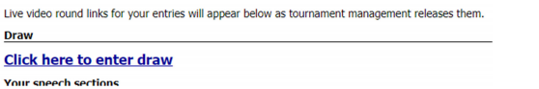
Once they click that link, they will see a summary of their day’s draws, along with links to draw now for any rounds that they have a draw open in:
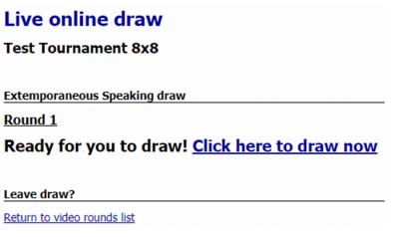
Once they click “Click here to draw now”, they will receive choices of questions:
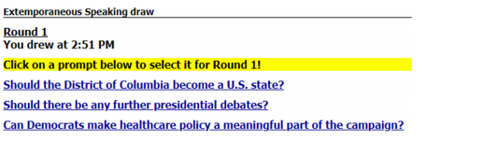
Other Draw Reminders
Extemp Speakers are only allowed to use one side of one 3’’ x 5’’ note card during the delivery of the speech.

Discussion Tasks
Discussion tasks will come from the following parts of the outline:
Section 1 Subtopic A, Section 2 Subtopic D, Section 3 Subtopic C and D

Discussion Tasks will appear here for each round.

Timing
Each speech event has a 30 second “grace period”. The ranking is up to the individual judge’s discretion. The judge should provide any reasonable set of time signals. The speaker may also ask for time signals. Any speaker going past the 30 second “grace period” will be stopped so we can remain on time.

Judge Obligations and Information

We will have a judge’s meeting at 8:40 in the judge’s lounge. (FACTS and Art Rooms) All judges should plan to be available for the entire tournament. Please click “Start” on your ballot when you are in the room and ready to begin - this lets the Tab Room know the round has begun. It is okay to break the speaker order on the ballot to accommodate cross-entries or missing students.

An Overview of Speechwire for Judges
Are you a judge who is set to judge a tournament on SpeechWire soon using electronic ballots? The video talks about speech, debate and congress e-ballots, as well as how they integrate with various asynchronous/synchronous tournament approaches.
Watch 'Judging Speech and Debate on SpeechWire with Electronic Ballots' on YouTube

Ballot/Critique Writing
Judges must rank all the way out. There will be no speaker points awarded at this tournament. The most important role of the judge is to write thoughtful and thorough critiques. We use your critiques to improve student performance. Many students are new to Speech this year and need encouragement. All students (and coaches!) appreciate positive, constructive feedback.

Do not penalize a student for what you believe to be an infraction of the rules.
Stop by the TAB Room if you have any questionable occurrences.

Do not wait until the speaker has finished to begin typing your ballot. Feel free to use any of the following templates (make a copy) if they’re helpful to you:

E-Critique Template
E-Critique Template with Grid
E-Critique Discussion Flow

When the round has concluded and you have ranked the speakers, you MUST submit and confirm your ballot immediately. If you have not completed your comments by this point, you must still SUBMIT THE BALLOT. After submission, you can return to add additional comments and feedback by re-opening your ballot.

Statement on Implicit Bias
We are all influenced by implicit bias, or the stereotypes that unconsciously affect our decisions. When judging, our implicit biases negatively impact traditionally marginalized and disenfranchised students. Before writing comments or making a decision, please take a moment to reflect on any biases that may impact your decision making.

To ensure a more equitable experience for our participants, please be sure your decision making process and comments are related only to the content and quality of the presentation itself.

